|  |
| --- |
| **M.01 VASODILATORS AND TREATMENT OF ANGINA PECTORIS**  ***DR. DAVE PADILLA I SEPTEMBER 22,2025*** |
| 1. INTRODUCTION 1 2. PATHOPHYSIOLOGY OF ANGINA 1 3. PHARMACOLOGY OF DRUGS USED TO TREAT ANGINA PECTORIS 2 4. NITRATES 2 5. NICORANDIL 4 6. CCB’s 4 7. BETA BLOCKERS 5 8. RANOLAZINE 5 9. TRIMETAZIDINE 5 10. IVABRADINE 5 11. SUMMARY 4 12. Checkpoint 6 13. References 6 |

|  |
| --- |
| 1. **INTRODUCTION** |

* **Angina pectoris**: chest pain caused by accumulation of metabolites resulting from myocardial ischemia.
* Most common cause of angina is atheromatous obstruction of the large coronary vessels.
* Types of Anginas:
* **Classic or Effort Angina**: Inadequate flow in the presence of coronary artery disease.
* **Prinzmetal or Vasospastic Angina**: Causes significant myocardial ischemia and pain
* **Unstable or Acute coronary syndrome**: episodes of angina occur at rest.
* In the heart, a **balance between myocardial oxygen supply and demand is important to avoid angina.**
* Three factors of Demand:
* **Heart rate**
* **Contractility**
* **Systolic wall tension**
* **↑ heart rate = ↑ contractility= ↑ systolic wall tension,** therefore If you have Hypertrophy or Cardiac enlargement/ thickening = **↑ OXYGEN DEMAND**.
* **SUPPLY**: determined by the **oxygen carrying capacity**, meaning the Oxygen-Hemoglobin dissociation curve and **coronary blood flow** which happens in the diastolic phase.
* **VASCULAR RESISTANCE**: determines the **amount of oxygen delivered in the blood.**
* **Metabolic control, Autoregulation, Extravascular Compressive forces, Humoral factor & Neural control.**
* Determine or contribute to the state of vascular resistance whether the blood vessels **dilate or constrict.**
* If there is **imbalance**, meaning less supply or more demand, the patient may have ANGINA.

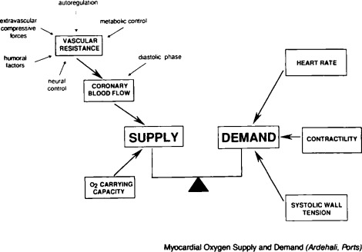

**Figure 1.** Myocardial Oxygen Supply and Demand

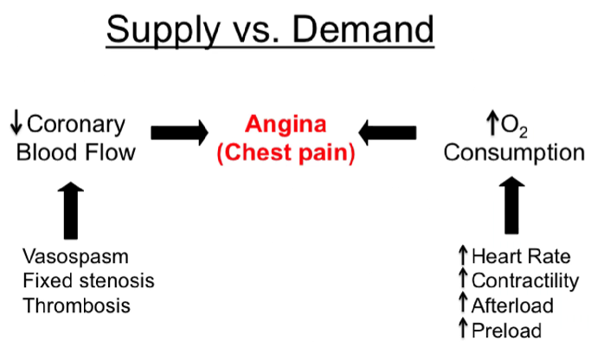

**Figure 2.** Supply vs Demand.

* **↑Oxygen Consumption = Greater Demand** due to the following:
  + Tachycardia
  + Increase heart rate
  + Greater contractility
  + More pumping force of the heart
  + Greater afterload
    - **Vasoconstriction** of the peripheral blood vessels or increased preload will lead to a **GREATER OXYGEN CONSUMPTION.**
* Angina could occur if there is decreased coronary blood flow exemplified by the following:
  + **VASOSPASM** – ex. Prinzmetal Angina
  + **FIXED STENOSIS** - coronary artery disease
  + **THROMBOSIS** - Acute myocardial infarction

|  |
| --- |
| 1. **PATHOPHYSIOLOGY OF ANGINA PECTORIS** |

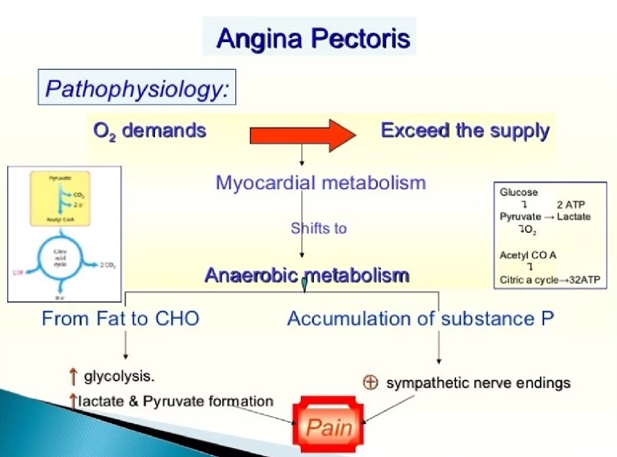

**Figure 3.** Pathophysiology of Angina Pectoris.

* In biochemical pathophysiology, **when oxygen demands exceed the supply, myocardial metabolism shifts from aerobic to anaerobic metabolism.**
* Metabolism from fat is shifted to carbohydrates which **increases glycolysis and increases lactate and pyruvate formation** causing **pain.**
* **Accumulation of substance P** which **activates the sympathetic nerve endings and causes pain** which is the characteristic of angina pectoris.
* Myocardial ischemia develops when coronary blood flow becomes inadequate to meet myocardial oxygen demand.
* Causes myocardial cells **to switch from aerobic to anaerobic metabolism**, with a progressive impairment of metabolic, mechanical, and electrical functions.
* Studies shown that **ADENOSINE** may be the main chemical mediator of angina pain.
* During **Ischemia**, **ATP is degraded to adenosine**, which after diffusion to the extracellular space**, causes Arteriolar dilation and Anginal pain.**

|  |
| --- |
| 1. **PHARMACOLOGY OF DRUGS USED TO TREAT ANGINA** |

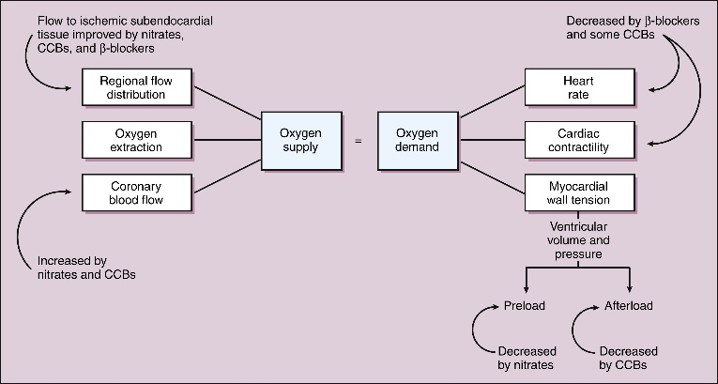**Figure 4.** Mechanism of Antianginal Drugs.

* **OXYGEN DEMANDS**:
* **Beta-blockers (BBs) and some calcium channels blockers (CCBs)** **decrease heart rate and contractility**, which decreases oxygen demand.
* **Certain CCBs** **dilate the blood vessels** thereby **decrease in afterload**.
* **Nitrates** **decrease preload by Venodilation**.
* If preload is decreased, the myocardial wall tension is also decreased, therefore oxygen demands are decreased, thus mitigating angina.
* **OXYGEN SUPPLY**:
* **CCBs, BBs and Nitrates** can direct flow to ischemic subendocardial tissue. Therefore, regional blood flow is improved = improving the state of angina.
* **Nitrates and CCB’s** increases coronary blood flow**.**

|  |  |
| --- | --- |
| ***OXYGEN SUPPLY*** | ***OXYGEN DEMAND*** |
| Regional flow distribution | Heart rate |
| Oxygen extraction | Cardiac contractility |
| Coronary blood flow | Myocardial wall tension |

**Table 1.** Determining factors of oxygen supply and demand.

|  |  |  |
| --- | --- | --- |
| ***DRUG CLASS*** | ***OXYGEN SUPPLY*** | ***OXYGEN DEMAND*** |
| ***Nitrates*** | ↑ Coronary blood flow, Improved regional flow | **↓ Preload** = ↓ myocardial wall tension |
| ***Beta- blockers*** | Improve subendocardial perfusion (indirect) thus improved regional flow | ↓ HR  ↓ Contractility |
| ***CCB*** | ↑ Coronary flow, Improved regional flow distribution | **↓ Afterload** = ↓ Myocardial wall tension |

**Table 2.** Summary of drug class in oxygen supply and oxygen demand.

|  |
| --- |
| 1. **NITRATES** |

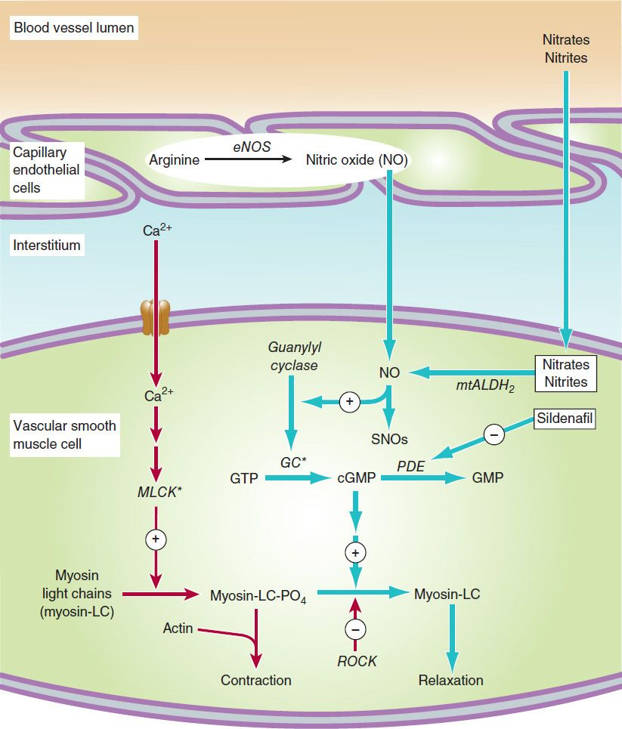

**Figure 5.** Mechanism of action of nitrates, nitrites, and other substances that increase the concentration of nitric oxide (NO) in vascular smooth muscle cells. Steps leading to relaxation are shown with blue arrows. MLCK*, activated myosin light-chain kinase. Nitrosothiols (SNOs) appear to have non-cGMP-dependent effects on potassium channels and Ca2+- ATPase. eNOS, endothelial nitric oxide synthase;GC*, activated guanylyl

cyclase: mtALDH2+ mitochondrial aldehyde dehydrogenase-2; PDE, phosphodiesterase; ROCK, Rho Kinase.

|  |  |
| --- | --- |
| **A1.** | **PHARMACODYNAMICS** |

* Nitrates can cause **VASODILATION,** therefore increase in Oxygen supply.
* In a normal blood vessel, there is adequacy of **ARGININE** which is activated upon by endothelial **nitric oxide synthetase (eNOs), converting it to Nitric Oxide.**
* This will **activate guanylyl cyclase**, which **converts GTP into cyclic GMP and the CGMP** **inactivates the myosin light chain phosphate (MLCP)** which causes **CONTRACTION.**
* In the inactivated form, there is smooth muscle relaxation → **VASCULAR DILATATION**
* In coronary arteries with blockages or coronary artery disease, there is lack of Nitric oxide.
* If a patient is given Nitrates or Nitrites, these are activated upon by the mitochondrial enzyme, **Aldehyde dehydrogenase converting it to Nitric Oxide from Nitroglycerin.**
* Once converted to Nitric oxide, **guanylyl cyclase is activated, which converts GTP into CGMP. The CGMP inactivates the MLCP** causes **relaxation or vasodilation, ↑ in Oxygen supply** thereby angina is improved.
* Nitroglycerin can be **denitrated by Glutathione S-transferase in smooth muscle and other cells.**
* Mitochondiral enzyme, Aldehyde dehydrogenase Isoform 2 (ALDH2) and possibly Isoform 3 (ALDH3) appears to be the key in the inactivation and release of Nitric Oxide from Nitroglycerin.
* **Nitric oxide** (probably complexed with Cysteine) **combines with the heme group of soluble guanylyl cyclase**, activating that enzyme and causing an **increase in CGMP causing relaxation.**

|  |  |
| --- | --- |
| **A2.** | **PHARMACOKINETICS** |

* Liver has high-capacity nitrate reductase hence, **oral bioavailability of nitrates is low**
* If you want **acute relief**, it can be given **sublingual** to bypass first pass effect.
* **HALF-LIFE:6-8 minutes**
* **Denitrated form has 3-hour half-life**.
* Excretion is largely via the **kidneys.**
* Nitroglycerin relaxes all types of smooth muscles regardless of the cause of preexisting muscle tone but has no direct effect on cardiac and skeletal muscle.
* All segments of the vascular system from large arteries through large veins relax in response to Nitroglycerin.
* Most evidence suggests a gradient of response, with **veins responding at the lowest concentrations and arteries at slightly higher ones.**
* The epicardial coronary arteries are sensitive, but concentric atheromas can prevent significant dilation.

|  |  |
| --- | --- |
| **A2.** | **TOXICITY AND TOLERANCE** |

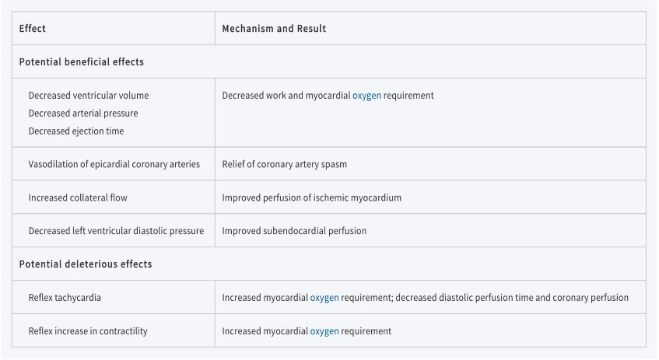

**Figure 6.** Beneficial and Deleterious Effects of Nitrates in the Treatment of Angina.

* **Reflex Tachycardia**
  + Because there is a **decrease in PRELOAD**, the heart will compensate by **increase HEART RATE** in order to maintain homeostasis.
  + Patients have **increased oxygen demand** therefore may contribute to angina.
* **Reflex increase in contractility**
* **VENODILATION, CONTRACTILITY & HEART RATE increases** which is a normal response of the heart if there is a decreased ventricular volume.
* Continuous exposure to nitrates, **isolated smooth muscle may develop complete tolerance or tachyphylaxis.**
* Diminished release of nitric oxide resulting from reduced bioactivation may be partly responsible for tolerance to nitroglycerin.
* Patient on chronic nitrates can have tolerance.
* **Supplementation of cysteine** may partially reverse tolerance, suggesting that reduced availability of sulfhydryl donors may play a role.
  + A nitrate-free regimen can also be an option.
  + For example, if the patient has nitrate patch, you can apply the patch from 8am-8pm and a nitrate-free duration in order to avoid tolerance to nitroglycerin.

|  |  |
| --- | --- |
| **A2.** | **ACUTE ADVERSE EFFECTS** |

* The major acute toxicities of organic nitrates are direct extensions of therapeutic vasodilation.
* **Orthostatic hypotension**
* **Tachycardia**
* **Throbbing headache**
* **Glaucoma,** once thought to be a contraindication, **does not** worsen, and **nitrates can be used safely in the presence of increased intraocular pressure.**
* Nitrates are **contraindicated,** however, if **intracranial pressure is elevated.**
* E.g. When the patient has intracranial hemorrhage.

|  |
| --- |
| 1. **NICORANDIL** |

* **Nicotinamide nitrate ester** or derivative that has vasodilating properties in normal coronary arteries but more complex effects in patients with angina.
* Recent studies in isolated myocytes indicate that the drug **activates an Na+ /Ca2+ exchanger and reduces intracellular Ca2+ overload.**
* Ca causes vascular contraction so if you interfere with Ca overload, vascular dilatation occurs thus increasing vascular supply.
* Clinical studies suggest that it **reduces both preload and afterload**. It also provides some myocardial protection via preconditioning by activation of cardiac K-ATP channels.
* **Preconditioning:** when the heart is subjected to ischemia, you can have collaterals (bridges between normal blood vessels to ischemic blood vessels) so you have greater collateral flow and also **preconditioning “resistance of the heart to ischemic conditions”.**
* One large trial showed a significant reduction in relative risk of fatal and nonfatal coronary events in patients receiving the drug.

|  |
| --- |
| **C. CALCIUM CHANNEL BLOCKERS** |

* Two types of calcium channel:
* T-type
* L-type (Dominant type)
* **The voltage-gated L type** is the dominant type of calcium channel in cardiac and smooth muscle and contain several drug receptors.
* It consists of **α1 (the larger, pore-forming subunit), α2, β, γ, and δ subunits.** Four variant α1 subunits have been recognized.
* **Nidefipine and other dihydropyridines** have been demonstrated **to bind to one site on the a-1 subunit**.
* **Non-dihydropyridines, Verapamil and diltiazem** appear to bind to closely related but not identical receptors in **another region of the same subunit.**
* Binding of the drug reduces the frequency of opening in response to depolarization. The result is a marked **decrease in transmembrane calcium current**, which in smooth muscle results in **long lasting relaxation** and in cardiac muscle results in **reduction in contractility throughout the heart** and **decreases in sinus node pacemaker rate and atrioventricular node conduction velocity.**

|  |  |
| --- | --- |
| **C1.** | **MECHANISM OF ACTION OF CCB’s** |

* Binding of the drug reduces the frequency of opening in response to depolarization.
* The result is a marked **decrease in transmembrane calcium current,** which in **smooth muscle results in long lasting relaxation** and in c**ardiac muscle results in reduction in contractility** throughout the heart and **decreases in sinus node pacemaker rate and atrioventricular node conduction velocity.**

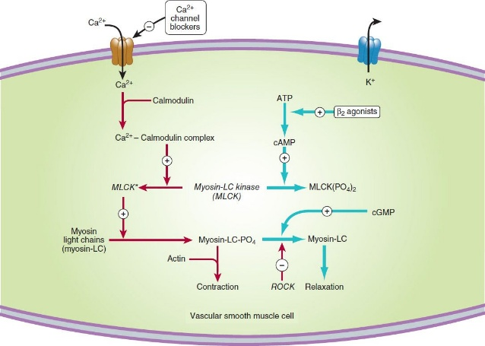

**Figure 7**. A simplified diagram of smooth muscle contraction and the site of action of calcium channel-blocking drugs. Contraction is triggered (red arrows) by influx of calcium (which can be blocked by calcium channel blockers) through transmembrane calcium channels. The calcium combines with calmodulin to form a complex that converts the enzyme myosin light-chain kinase to its active form (MLCK*). The latter phosphorylates the myosin light chains, thereby initiating the interaction of myosin with actin. Other proteins, including calponin and caldesmon (not shown), inhibit the ATPase activity of myosin during the relaxation of smooth muscle. Interaction with the Ca2+-calmodulin complex reduces their interaction with myosin during the contraction cycle. Beta2 agonists (and other substances that increase cAMP) may cause relaxation in smooth muscle (blue arrows) by accelerating the inactivation of MLCK and by facilitating the expulsion of calcium from the cell (not shown). cGMP facilitates relaxation by the mechanism shown in Figure 7. ROCK, Rho kinase.

* Ca enters the cell via the L- type calcium channels which are blocked by CCBs.
* Ca interacts with calmodulin producing a **Ca-calmodulin complex activating activates myosin light chain kinase.**
* Myosin light-chain kinase phosphorylates myosin light chains and these phosphorylated myosin light chains interact with actin causing contraction.
* **If you block the Ca, you block the whole pathway causing vascular smooth muscle relaxation.**
* Therefore, if you have **smooth muscle relaxation** you have **vasodilation = ↓ preload, ↓ afterload, ↓ HR.**

|  |  |
| --- | --- |
| **C2.** | **EFFECTS ON SMOOTH MUSCLE** |

* In the vascular system, **arterioles appear to be more sensitive than veins.**
* Orthostatic hypotension is not a common adverse effect compared with nitrates.
* **BP is reduced with all calcium channel blockers.**
* The reduction in peripheral vascular resistance is one mechanism by which these agents may benefit the patient with angina of effort.
* Reduction of coronary artery spasm has been demonstrated in patients with variant angina.

|  |  |
| --- | --- |
| **C3.** | **EFFECTS ON CARDIAC MUSCLE** |

* Impulse generation in the sinoatrial node and conduction in the atrioventricular node—so called **slow-response, or calcium dependent**, **action potentials**—may be **reduced or blocked by all of the calcium channel blockers.**
* Excitation-contraction coupling in all cardiac cells requires calcium influx, so these drugs reduce cardiac contractility in a dose-dependent fashion.
* In some cases, cardiac output may also decrease.
* This **reduction in cardiac mechanical function** is another mechanism by which the calcium channel blockers can reduce the oxygen requirement in patients with angina.

|  |  |
| --- | --- |
| **C4.** | **MECHANISM OF CLINICAL EFFECTS** |

* CCBs are **negative inotropic** meaning they **decrease myocardial contractile force**, which **reduces myocardial oxygen requirements.**
* CCBs in arterial smooth muscle decreases arterial and intraventricular pressure.
* Some of these drugs (e.g. verapamil, diltiazem) also possess a **nonspecific antiadrenergic effect**, which may contribute to **peripheral vasodilation**.
* As a result of all of these effects, **left ventricular wall stress declines,** which **reduces myocardial oxygen requirements.**
* **Decreased heart rate** with the **use of verapamil or diltiazem causes a further decrease in myocardial oxygen demand.**
* CCBs also relieve and prevent focal coronary artery spasm in variant angina.
* Use of these agents has thus emerged as the **most effective prophylactic treatment for this form of angina pectoris.**
* Prinzmetal angina/vasospasm variant of angina, use of CCBs specifically Verapamil and Diltiazem to improve angina.

|  |
| --- |
| **D. BETA BLOCKERS** |

* **1st line in treating angina.**
* The beneficial effects of β-blocking agents are related to their hemodynamic effects— **decreased heart rate, blood pressure, and contractility** (negative chronotropic & inotropic)—which **decrease myocardial oxygen requirements at rest and during exercise.**
* Lower heart rate is associated with an increase in diastolic perfusion time (Oxygen supply happens during diastolic phase; lower HR, increased diastolic time thus, increased perfusion time of the heart) that may increase coronary perfusion.
* However, **reduction of heart rate and blood pressure**, **and consequently decreased myocardial oxygen consumption**, appear to be the most important mechanisms for relief of angina and improved exercise tolerance.
* Beta Blockers may also be valuable in treating **silent or ambulatory ischemia.**

|  |  |
| --- | --- |
| **D1.** | **UNDESIRABLE EEFECTS OF BETA BLOCKERS IN ANGINA** |

* ↑ in end-diastolic volume and ↑in ejection time, = ↑ myocardial oxygen requirement.
* These **deleterious effects of β-blocking agents can be balanced by the concomitant use of nitrates.**
* **Contraindications** to the use of β blockers are asthma and other bronchospastic conditions (e.g. COPD), severe bradycardia, atrioventricular blockade, bradycardia-tachycardia syndrome, and severe unstable left ventricular failure.
* Because they are negative inotropic agents so decrease in the pumping force of the heart.
* Using beta blockers in these conditions, especially in acutely decompensated patients, is relatively contraindicated.
* Potential complications include **fatigue, impaired exercise tolerance, insomnia, unpleasant dreams, worsening of claudication, and erectile dysfunction.**

|  |
| --- |
| **E. RANOLAZINE** |

* Appears to act by **reducing a late sodium current (INa)** that **facilitates calcium entry via the sodium-calcium exchanger**.
* The reduction in intracellular calcium concentration that results from ranolazine reduces **diastolic tension, cardiac contractility, and work.**
* Considered as a Calcium blocker.

|  |
| --- |
| **F. TRIMETAZIDINE** |

* Certain metabolic modulators are known as **pFOX inhibitors** because they **partially inhibit the fatty acid oxidation pathway in myocardium.**
* Because metabolism shifts to oxidation of fatty acids in ischemic myocardium, the oxygen requirement per unit ATP produced increases.
* Partial inhibition of the enzyme required for fatty acid oxidation (long-chain 3-ketoacyl thiolase, LC-3KAT) appears to improve the metabolic status of ischemic tissue.

|  |
| --- |
| **G. IVABRADINE** |

* Relatively **selective funny (If) sodium channel blockers**, **reduce cardiac rate by inhibiting the hyperpolarization-activated sodium channel in the SA node.**
* **Ivabradine causes decrease in HR**
* No other significant hemodynamic effects have been reported.
* Ivabradine appears to reduce anginal attacks with an efficacy similar to that of calcium channel blockers and beta-blockers.
* The **lack of effects on GI and bronchial smooth muscle is an advantage of ivabradine**, and it is **approved for use in angina and heart failure outside the USA.**
* Ivabradine is European medication which can be an alternative to beta blocker in asthmatic patients, where beta blockers are contraindicated.

|  |
| --- |
| 1. **SUMMARY** |

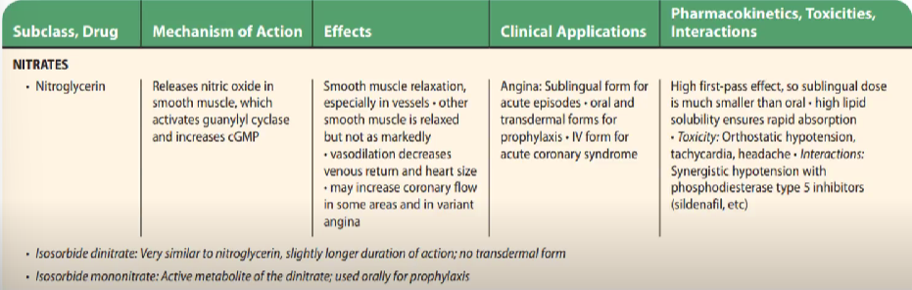

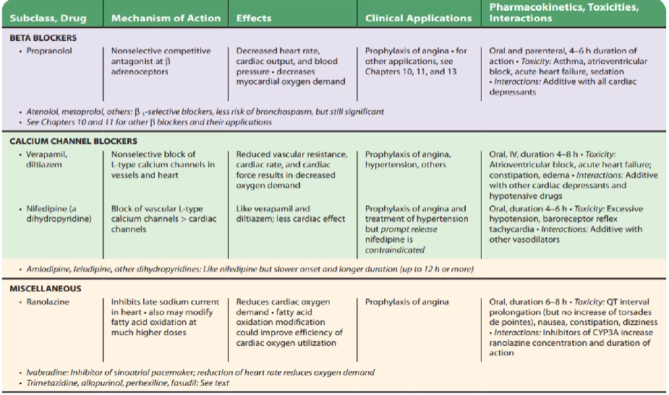

|  |  |  |  |
| --- | --- | --- | --- |
|  | **NITRATES ALONE** | **B-BLOCKERS OR CCB’S** | **COMBINED NITRATES WITH B-BLOCKERS OR CCB’S** |
| **HR** | Reflex increase | Decrease | Decrease |
| **ARTERIAL PRESSURE** | Decrease | Decrease | Decrease |
| **END-DIASTOLIC PRESSURE** | Decrease | Increase | None or decrease |
| **CONTRACTILITY** | Reflex increase | Decrease | None |
| **EJECTION TIME** | Decrease | Increase | None |

**Table 3.** Effects of nitrates alone and with B-blockers or CCBs in Angina Pectoris

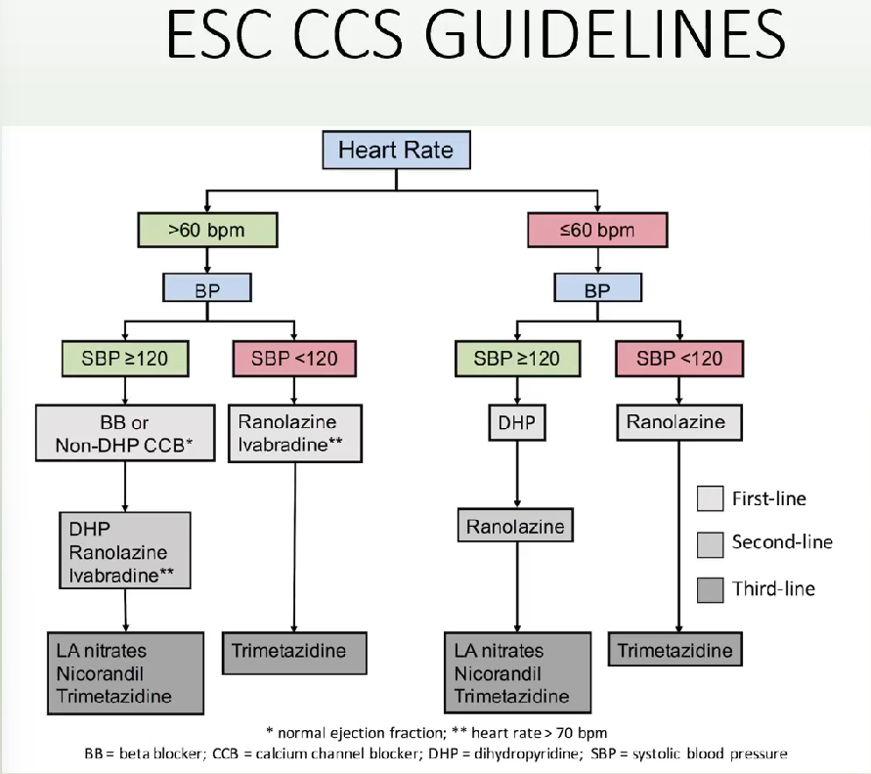

See if the patient has a HR of more than or less than 60.

If the **HR** **is more than 60,** determine the **BP** (Is the systolic BP less than or more than 120?) If it’s more than **120,** use:

* Beta blockers (metoprolol, atenolol, carvedilol) or non-dihydropyridines CCBs (verapamil, diltiazem).
* Class 2 Dihydropyridines CCBs, Ranolazine, Ivabradine
* Can add long-acting nitrates, Nicorandil, Trimetazidine (TMZ) if the patient still has angina

If the **HR is more than 60 but the BP is relatively low**, we can use:

* Ranolazine, Ivabradine
* Can add TMZ if the patient still has angina

If the patient is **relatively bradycardic.** Determine if the patient has a BP of more than or equal to 120

* If the patient has more than or equal to 120, use:
* Dihydropyridines (amlodipine, felodipine)
* Can add Ranolazine if the patient still has angina
* 2nd line agents include LA nitrates, Isosorbide Mononitrate (ISMN), Nitroglycerin (NTG) Patches, Nicorandil and TMZ

If the BP is low

* The 1st line will be Ranolazine and later can add TMZ to mitigate the angina of the patient

|  |
| --- |
| 1. **SUMMARY** |

Katzung, B. G. (Ed.). (2018). *Basic and clinical pharmacology* (14th ed.). McGraw-Hill Education.

Dr. Dave Padilla lecture and PPT